**Boston University**

**Electrical & Computer Engineering**

**EC463 Senior Design Project**

First Semester Report

The Future of Heat

Submitted to:

Marissa Petersile

National Grid

National Grid P.O. Box 960 Northborough, MA 01532-0960

1-800-322-3223

Marissa.Petersile@nationalgrid.com

by

**Team 17**

**The Future of Heat**

Team Members

Muayad Al Riyami - [mriyami@bu.edu](mailto:mriyami@bu.edu)

Ben Gross - [bengee19@bu.edu](mailto:bengee19@bu.edu)

Seunghak Shin - [seunghak@bu.edu](mailto:seunghak@bu.edu)

Fatima Dantsoho - [dantsoho@bu.edu](mailto:dantsoho@bu.edu)

Andrew Chen - [achen17@bu.edu](mailto:achen17@bu.edu)

Submitted: 12/13/2020

#### Table of Contents

Table of Contents 1

**Executive Summary** **1**

**Introduction** **3**

**Concept Development** **5**

**System Description** **6**

**First Semester Progress** **10**

**Technical Plan** **1**6

**Budget Estimate** **1**8

**Attachments** **1**9

**Appendix 1 – Engineering Requirements** **1**9

**Appendix 2 – Gantt Chart** **20**

**Appendix 3 – Other Appendices** **2**1

# Executive Summary

Future of Heat

17– Future of Heat

As global warming is becoming more severe, non-renewable energy such as natural gas and oil is falling out of favor. Using natural gas and oil to heat homes and businesses only continues to accelerate the warming of our planet. One of the promising alternatives is using electricity for heating. So we were tasked by National Grid to create an educational model that will teach the public about the benefits of electric heating and how it will affect grid systems in the future.

The final deliverable is a 3 feet by 3 feet diorama with built-in electronics which will be accompanied by an interactive web application. We decided to focus on heating simulations that would behave accordingly to the user inputs and programmed into the microcontroller. The outputs will be displayed using LEDs on the diorama as well as through the web application on the user’s screen.

A major innovative feature of this project is that it accommodates for the safety protocols regarding the pandemic by creating a contactless but interactive learning experience. Users can simply scan the QR code with a mobile device and use the web application to interact with the diorama to learn about the future of heat!

# Introduction

The electric and gas utility company, National Grid has a problem regarding modeling the effects of the newer trends in electric heating adoption and electric vehicle adoption on the power grid. As such, our client Ms. Petersile requires an interactive educational model that demonstrates the impact electric heating and peripherally electric vehicles will have, focusing on the following key metrics: carbon emissions, cost savings, and power demand.

With the current rate of human-caused carbon emissions, climate change not only threatens our current way of life, but our future as well. The current usage of natural gas-powered heating in commercial buildings and homes is a major contributor to anthropogenic carbon emissions. According to the EPA, commercial and residential heating of buildings contributes to at least 12% of GHG emissions. Robust methods to decarbonize heating are needed, one of which is the introduction of electric heating. These new types of electrical heat pumps are viable and sustainable for wide scale adoption. In addition, if the electricity used to power these heat pumps is sourced renewably, then the future of heat can be completely emission-free. Therefore, substantially reducing waste and pollution while gaining efficiency.

The Future of Heat project will demonstrate the impacts of electric heating on carbon emissions savings, the power demand on the grid, and the cost savings of installing electric heating. In summary, the Future of Heat project will provide an interactive educational tool that can teach the public about the benefits of widespread adoption of electric heating and why it is the wiser choice for the future.

Team 17’s approach to this problem includes a two part teaching tool, a diorama and an interactive web application. The diorama provides users with an appealing visualization of the grid, and the interactive web application allows users to interact with the diorama with ease.

The interactive web application will allow users to select various parameters to be tested. Once the user inputs are submitted, the web application will display the corresponding data and graphs that highlight the benefits of electric heating. Our users will also be able to observe real-time changes to the diorama, as LEDs will turn on, off, or change colors. The combination of a user-friendly web application and a dynamic and aesthetically-pleasing diorama will ensure an enjoyable learning experience for the users.

*Figure 1. Initial concept drawing of project*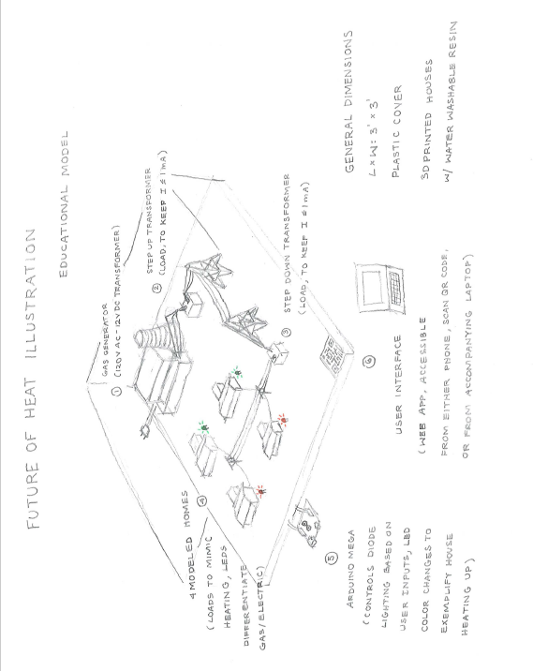

# Concept Development

The customer stated that they would need an interactive model which includes a hardware component, a physical model of a home with electric heat, and a software component, a UI screen that allows the user to test various conditions and observe how those conditions impact the system. They made it clear that the project was very open-ended and left us with plenty of room for creativity. We do understand that we need to produce an interactive 3D model that can educate people about the future of electric heat.

Given the open-ended nature, the team decided on using 4 model houses and a power plant to show how electric heating would work. Upon venturing down this path, we discovered it was rather short-ended on the technical side. We quickly realized that if we used DC for the grid, it could all be easily simulated on an Arduino which would drastically reduce the value of the circuit. Given this, we decided to forgo this purely resistive DC circuit, due to two main reasons, this modeling would be rather meaningless and would additionally result in a nonexistent technical side to this project. As such it was decided to move to a more robust AC model with upwards to 30 houses and a power plant. This new model will let us more realistically mimic an AC electrical grid with real and reactive power, and thus present a more realistic modeling implementation for effects various adoption rates for electrical heating will have on the power grid.

For the interactive teaching model, the team made the decision to use a web application. With the global pandemic at hand, personal hygiene and social distancing has been strongly encouraged. To accommodate for this problem, a safer design choice is to use a QR code that can be scanned, allowing the users to access the web application with their own device of choice.

# System Description

The system consists of three main components: the web application, the Arduino, and the diorama. Through the web application, users can select various values for temperature, electric heating adoption rate, and electric vehicle adoption rate. These values are used to produce output graphs that will be displayed in the web application and they will also be communicated to the Arduino. Then, the Arduino will use the input values to decide the house loads (electric heating consumes more power) and what color the LEDs will display (indicating information such as duration of heating and the source of heating energy). The same process applies to the interactive map; users highlight a component, the web application communicates the component ID to the Arduino which then turns on the corresponding LED.

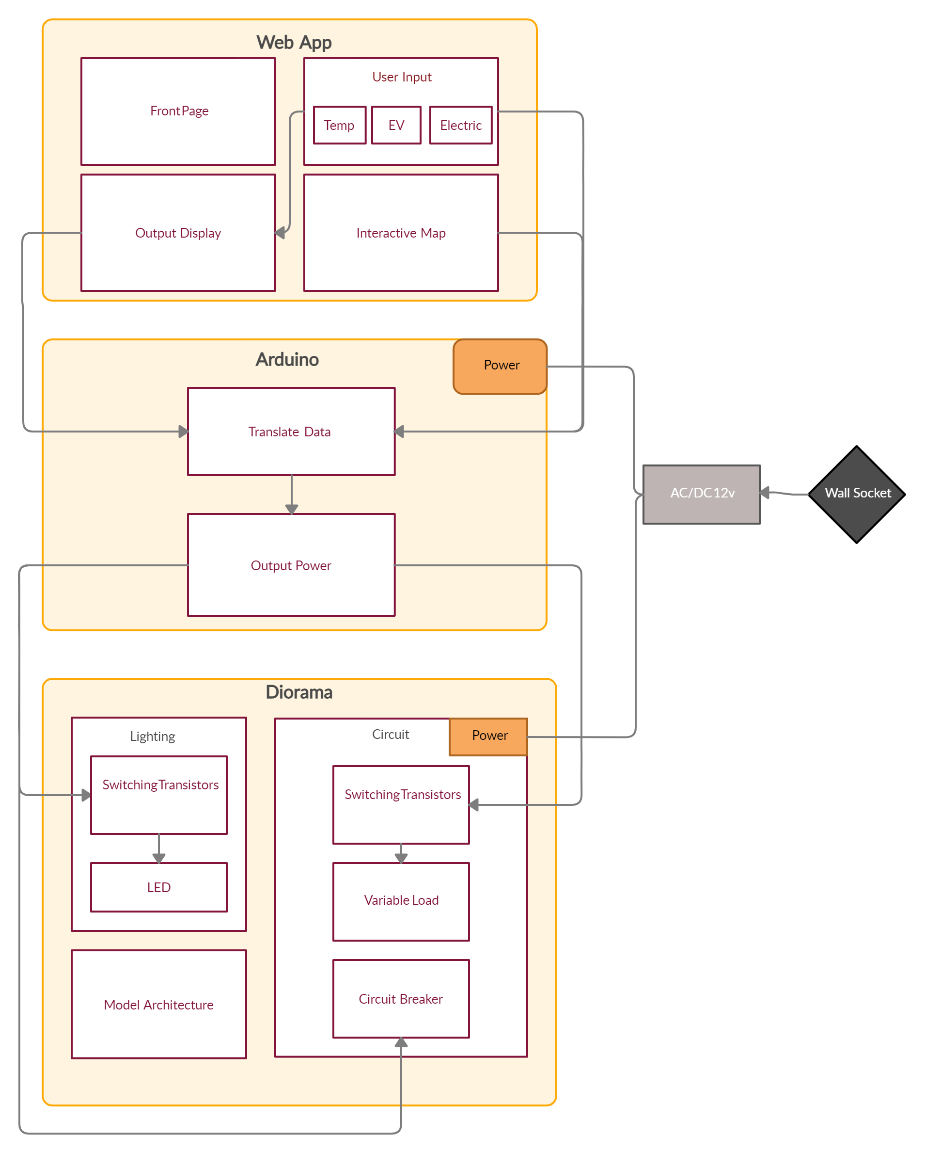

*Figure 3. System block diagram*

We will provide an interactive model that addresses and presents the effects of electric heating on the environment and the power grid. We will achieve this by providing the following system structure:

* 1. **Web Application**

The web application serves as the user interface. The user should have the ability to change the number of homes that have adopted electric heat, select various winter weather conditions (ie: warmest on record vs coldest on record, etc), and select adoption rates of electric vehicles. These variables are provided in the form of sliding bars to limit the inputs to meaningful values.

The web application will also feature an interactive map of the diorama, where users can highlight a component to get more information about it and highlight it in the physical model. Information provided through the map includes the function of a component in the power grid and how much power is passing through it or how much power it is consuming. This serves as an extra educational tool for users to learn about how the power grid works.

Finally, the web application will provide an output page, where all the results of the simulation will be presented to the user in an easy to digest form. The main outputs we are looking to present to the users are the data comparisons between electric and natural gas heating. Which includes cost of heating, and Greenhouse Gasses emissions. This is done by graphing the electric heat data and the natural gas heat data in the same plot (ie: a plot of cost of heating versus time of the year for both energy sources). In the same section, users will be able to get an insight on the compounding effects of EVs and electric heat adoption have on the power grid. This is accomplished by showing the users the toll such an increase in total load will put on the grid. So, a comparison between the power going through a grid component before and after EV and electric heat adoption is increased will serve to show quantitatively that increase in power.

* 1. **Arduino Mega 2560 Rev3**

The Arduino component of the project consists of three major components. The LED control for user interaction, the serial communication between the Arduino and the web application via Firebase, and the power loads’ reading and control for the model power grid.

The LED control component is made up of two different types of LEDs, a Red Green (R/G) Bicolor LED and a Red-Blue (R/B) Bicolor LED. The R/G LED will be used to display to the user which houses have electric heating and which houses have gas heating. This visual distinction will be tied to the user’s input of the adoption of electric heating. Additionally the R/B LED will be used to allow the user to visually see houses heating up. The time duration needed for the gradient transition from blue to red will depend on several factors including the user’s input temperature as well as the houses’ size. This time duration will be calculated on the backend of the web application, as such the Arduino only needs to control the color transition duration based on an input bus of bits and a case statement. For the purpose of modularity, the circuitry design for powering and controlling these LEDs will take advantage of decoders to multiplex signals together.

The serial communication component consists of interfacing the Arduino with the web app through the use of Firebase. The ESP8266 Wifi Module will be connected to Arduino via the RX and TX (transmitting and receiving) pins. Arduino’s prebuilt library for ESP8266 modules will be used to communicate an array of power load data to the web app wirelessly. Additionally, user input information regarding the electric heating adoption rate as well as heating times for the houses will be sent from the web application to the Arduino. As this component is estimated to have the longest run time, optimization here will be crucial to keep the responsivity of the model to within 5 seconds.

The power load readings and control component pertain to interactions between the Arduino and the circuitry meant to accurately model a power grid. As the power grid is planned to be AC there will be both reactive and real power present. Therefore the Arduino code will be modularly designed by creating a OOP library to calculate AC power flow equations in order to calculate real power. An array of power load data will be read in and then serially communicated to the web application’s backend.

* 1. **Diorama**

The diorama will be three foot by three foot. With 4 houses connected by a road and their electrical systems hooked up to a power plant in the corner of the diorama. The buildings and the surrounding area will be dealt with paint and fake foliage. Under the diorama will be a hollow area for the electronics to hide from public view.

When this diorama is completed work will be started on the other layout that has 30 houses in it. This will have city planning with a solar farm or power plant integrated into the diorama. it will be much smaller scale, all the techniques that can be applied to the other model will be applied to this one.

As mentioned each diorama will have a function space to hide circuitry in it. As well as a way to hook up all the building LEDs to the electronics with ease.

Another crucial component of the model is the circuitry. The circuitry will power all components of the project, that includes the “house loads”, the LEDs, and the Arduino. The circuit must be able to use a wall socket as the power source and it must also incorporate variable “house loads” that are representative of the difference of electrical versus natural gas heating. This means a house that is using electrical heating – and/or electric vehicle – will consume more power from the grid.

# First Semester Progress

* 1. **Web application**

*Figure 4. Web Application Front End Design*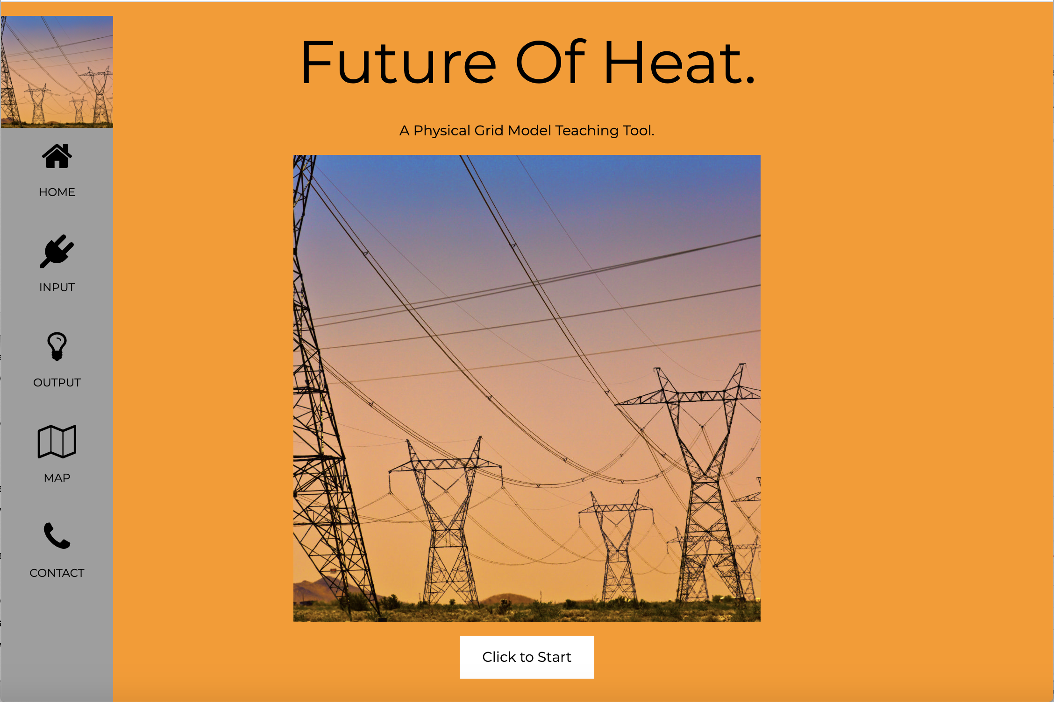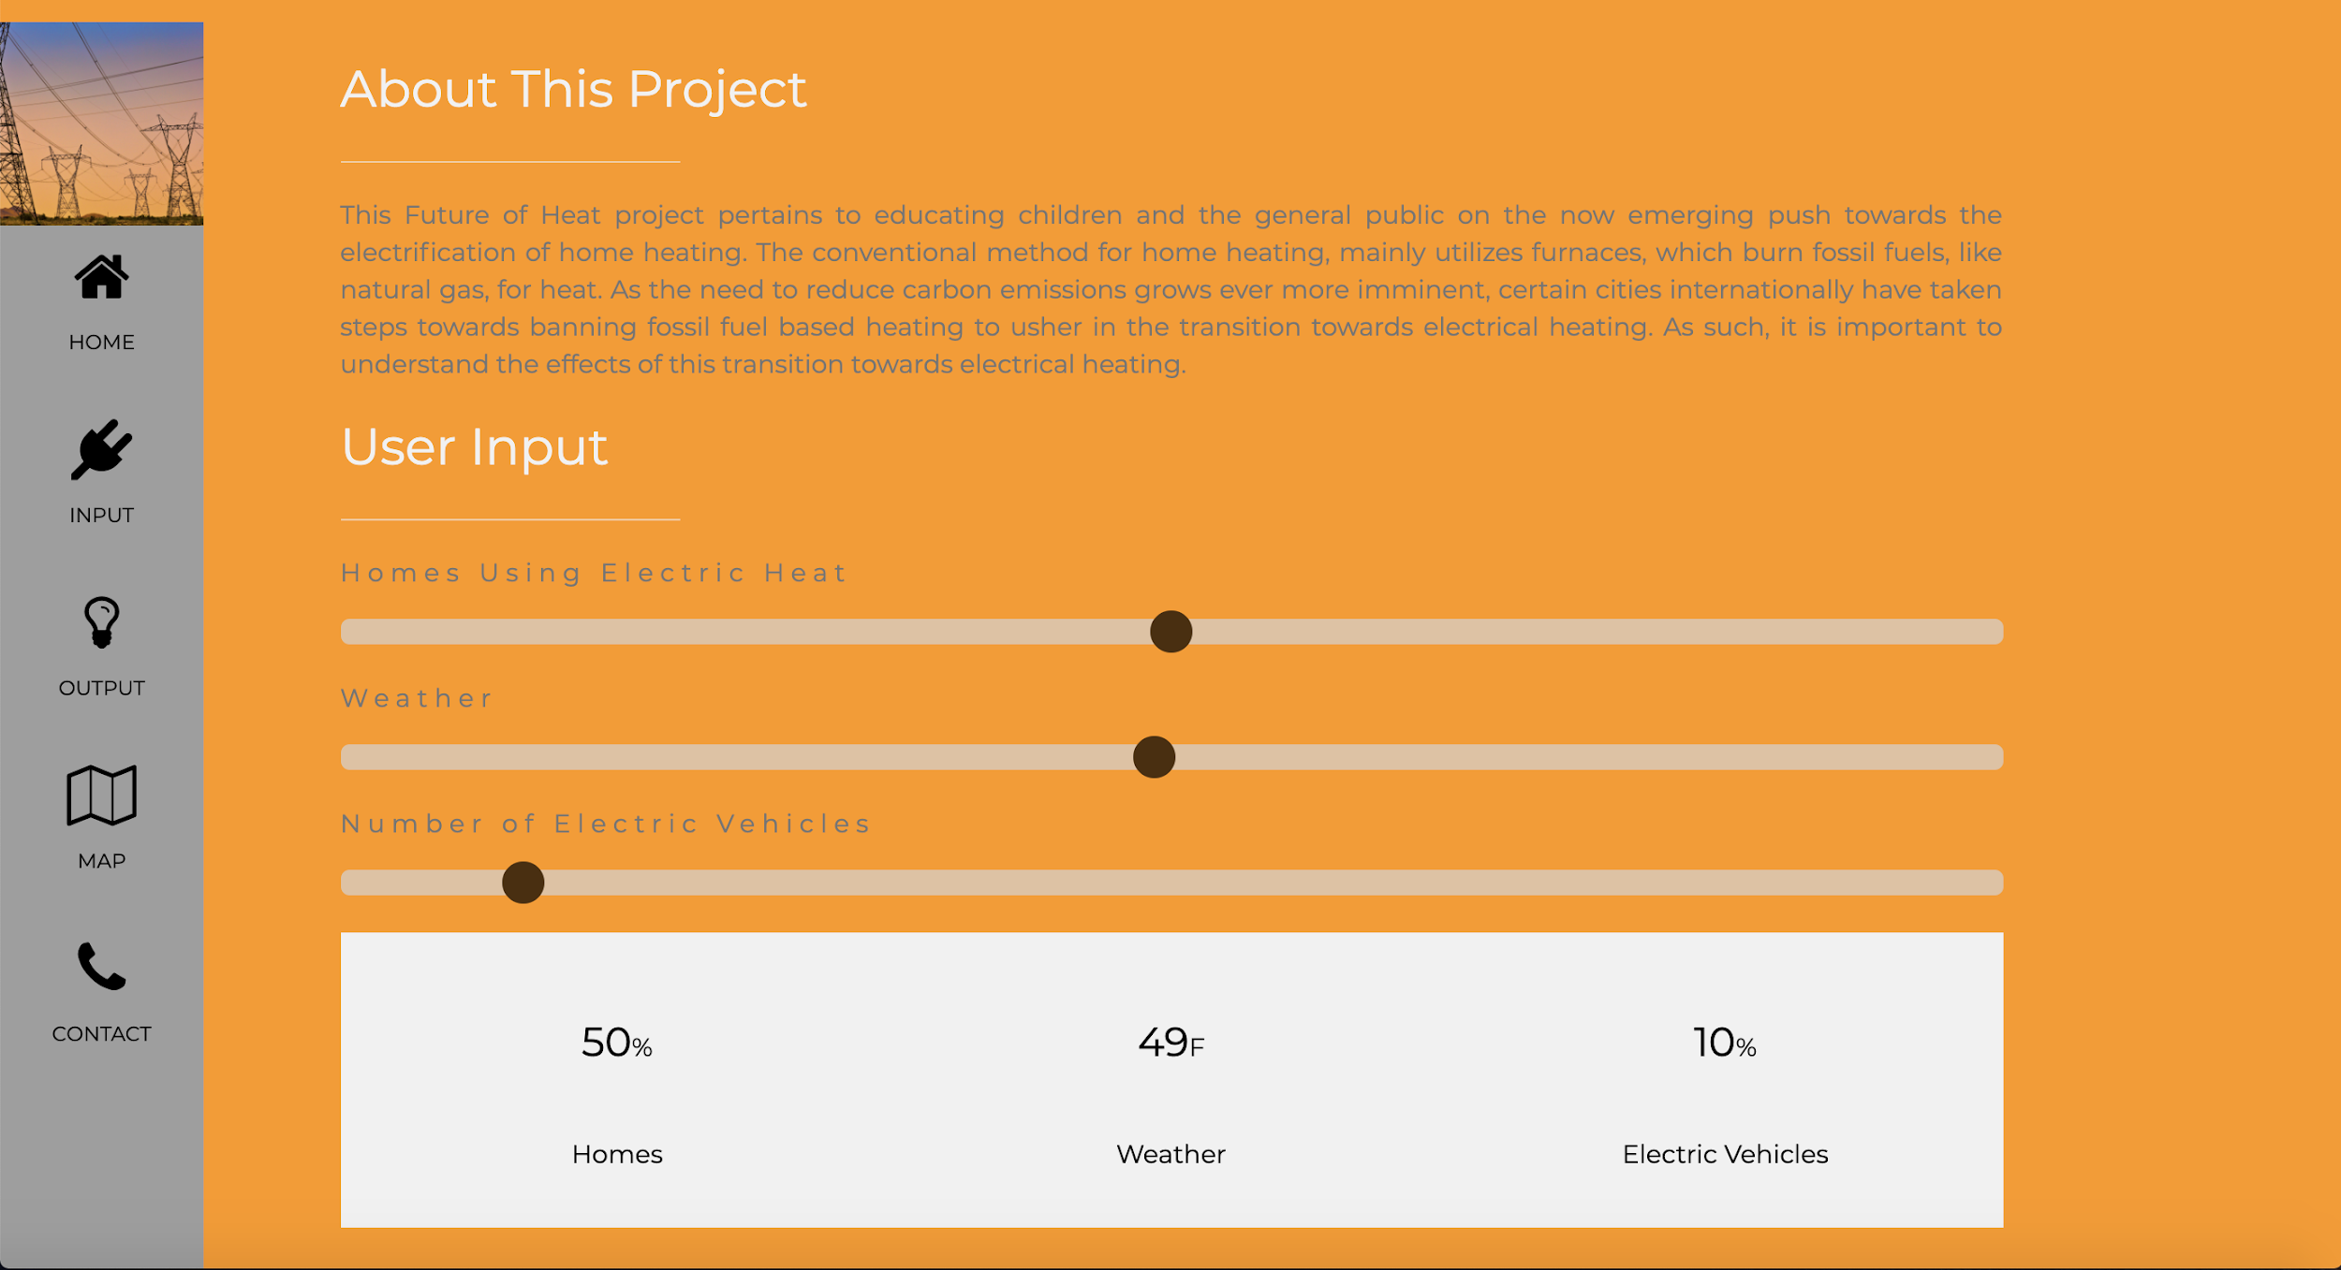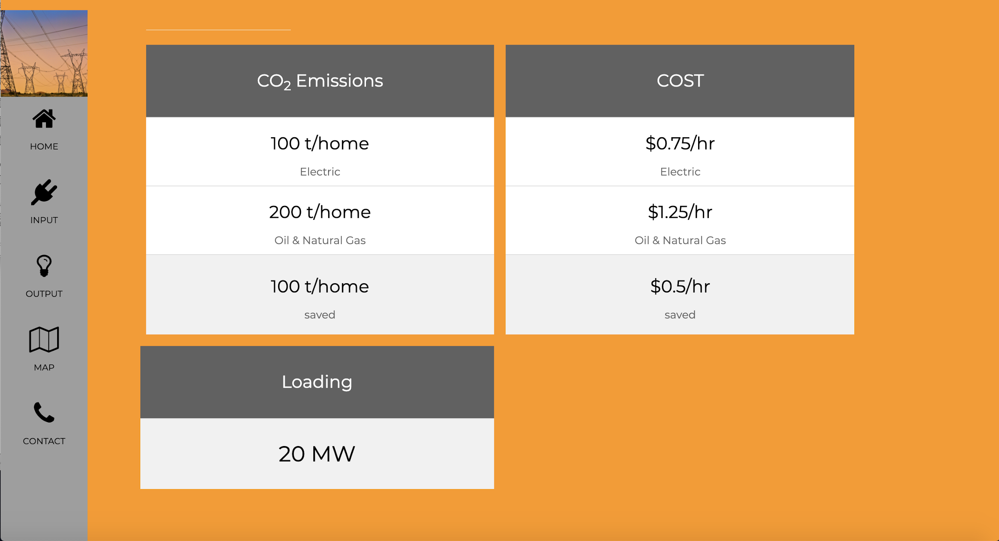

As seen in *Figure 4*, The front end web application was successfully implemented. The three user inputs will be received using range sliders. The range sliders make sure we do not have any input errors - the user will not be able to insert an illegal input or go out of the required range.

For the adoption rates of the electric homes and electric vehicles, they are measured by percentage with 10% step increases. The step increase might eventually be changed depending on the number of houses that are eventually 3-D printed. The output tables populate as the user inputs change.

The web application will be hosted on Firebase and will be communicating with the Arduino to send and receive data using firebase' realtime database feature. The created firebase scripts that will be added to the HTML code:

<!-- The core Firebase JS SDK is always required and must be listed first -->

<script src="/__/firebase/8.0.2/firebase-app.js"></script>

<!-- TODO: Add SDKs for Firebase products that you want to use

<https://firebase.google.com/docs/web/setup#available-libraries> -->

<script src="/__/firebase/8.0.2/firebase-analytics.js"></script>

<!-- Initialize Firebase -->

<script src="/__/firebase/init.js"></script>

Finally, our team has registered to get a unique API from the U.S Energy and Information administration. Currently, EIA’s API contains the following main data sets:

o Hourly electricity operating data, including actual and forecast demand, net generation, and the power flowing between electric systems

o 408,000 electricity series organized into 29,000 categories

o 30,000 State Energy Data System series organized into 600 categories

o 115,052 petroleum series and associated categories

o 34,790 U.S. crude imports series and associated categories

o 11,989 natural gas series and associated categories

o 132,331 coal series and associated categories

o 3,872 Short-Term Energy Outlook series and associated categories

o 368,466 Annual Energy Outlook series and associated categories

o 92,836 International energy series

* 1. **Arduino**

As of the end of the semester the arduino section of the project has shown a lot of progress. We have shown the arduino and the code written for it are able to turn on and off an LED light when given the parameters of a gas heated house versus an electrically heated house. This shows a preliminary proof of concept that one can in fact power LEDs logically. Furthermore, upon further inspection the current design for LED control is not as optimal as it can be, as I have designed all the LED’s to be powered by the Arduino, refer to Appendix 3. Although this method of powering the LEDs will work for 4 houses as more houses are added the current and voltage loads on the Arduino Mega far exceed its rated limits. As such further work with decoding LED control signals will be needed. Additionally there was a working proof of concept where the code is able to read the purely resistive power loading on the house. See Appendix 3 for a table showing the results of the Arduino voltage and power readings and its accuracy. The main concern with the probing of voltages is the ADC resolution limit imposed by the 210 bit depth which yields intervals of 0.004883 V. This resolution limit will be crucial especially when the prototype will be containing upwards of 30 houses. This concern is due to accuracy falling when the voltages being probed are closer in magnitude to the resolution limit, which in turn carries through into the power calculation magnifying the error. Even so, as seen in the prototype testing results as long as the voltages being probed are several orders of magnitude greater than this resolution limit the percent error is reasonable.

* 1. **Diorama**

The initial BOM was constructed, and sketches have been created and decided upon. *Figure 1* is a rough layout of what the diorama will look like. With this diorama does come the other one that will be developed. There has been no work this semester on this new idea except for some initial notes. The buildings have been giving me some trouble as I have gone on to scale them, initial prints were created and it was noticed that they were too small, so they will need to be upscaled and reprinted for the final product.

*Figure 2. Preliminary Diorama Houses CAD*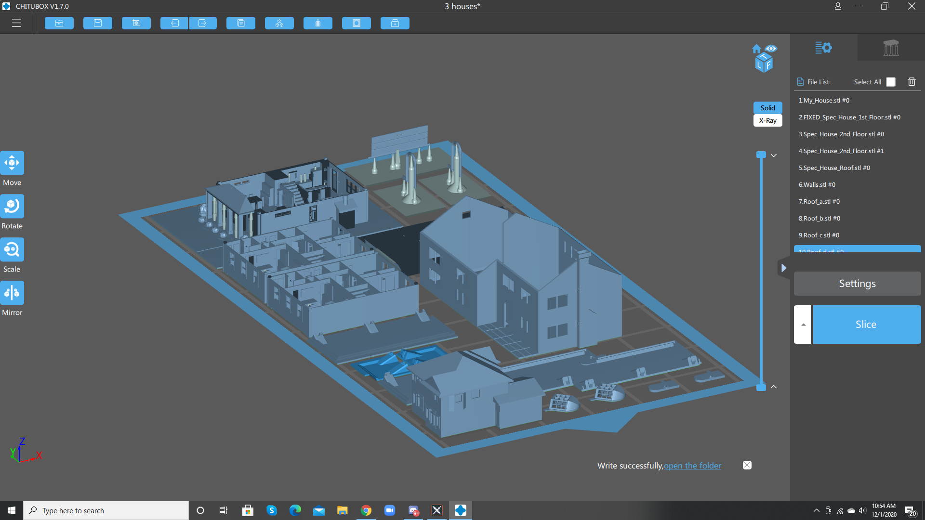

* 1. **Circuit**

The circuit design for a diorama consisting of four houses has been made, see Figure 4. We designed the following circuit so that it has variable house loads controlled by the Arduino and a transistor. This design presents four house units powered by the wall socket, but in the likely case that the team decides to add more house units, we can simply add more adjacent house units making sure that the power consumption increase does not go beyond what the power source can deliver. Note that each “PIN#” is connected to an Arduino pin. The house loads will be more than just two parallel resistors, the house units will have three resistor branches allowing for 23 different possible values when controlled by the Arduino. An updated version of the design had LEDs drawing power from the main power source instead of the Arduino, this was made in case the number of house units increased beyond the capabilities of the Arduino Uno. See figure 5 for the updated house unit design where it also shows a more accurate representation of the house load configuration as explained previously.

Also, we chose the model of all circuit components based on the design. The circuit components selected were:

* 120 V AC to 12 V DC power converter (Model TMPS 10-112) as the power source
* N-channel Enhancement Mode MOSFET (Model 2N7002-7-F) for all transistor switches

It is important to note that the team has decided to move on from DC and pursue the reach goal of AC power grid representation. Thus, some of the components of the circuit, like the AC to DC power converter, will not have to be added to the budget estimate.

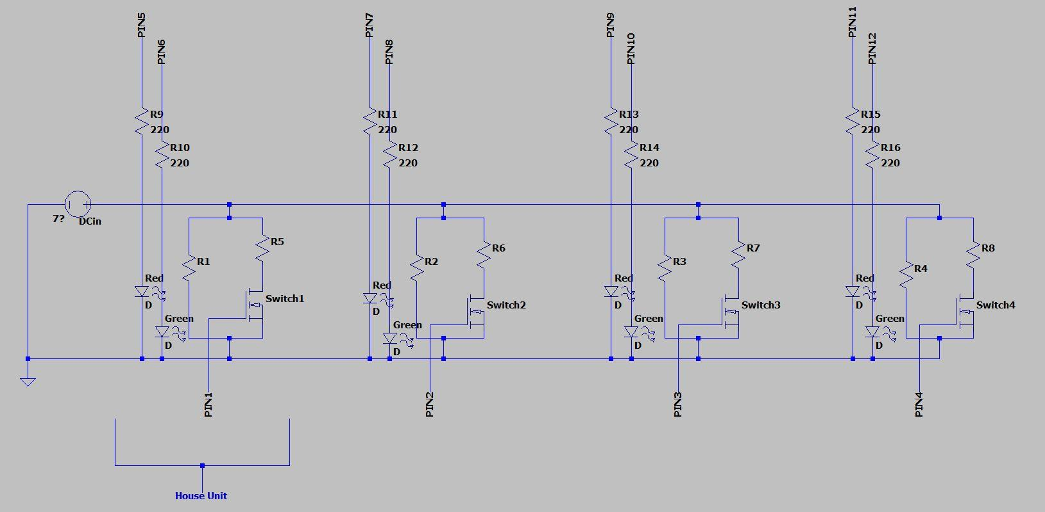

*Figure 4 : Preliminary Resistive Load Schematic of 4 House Units*

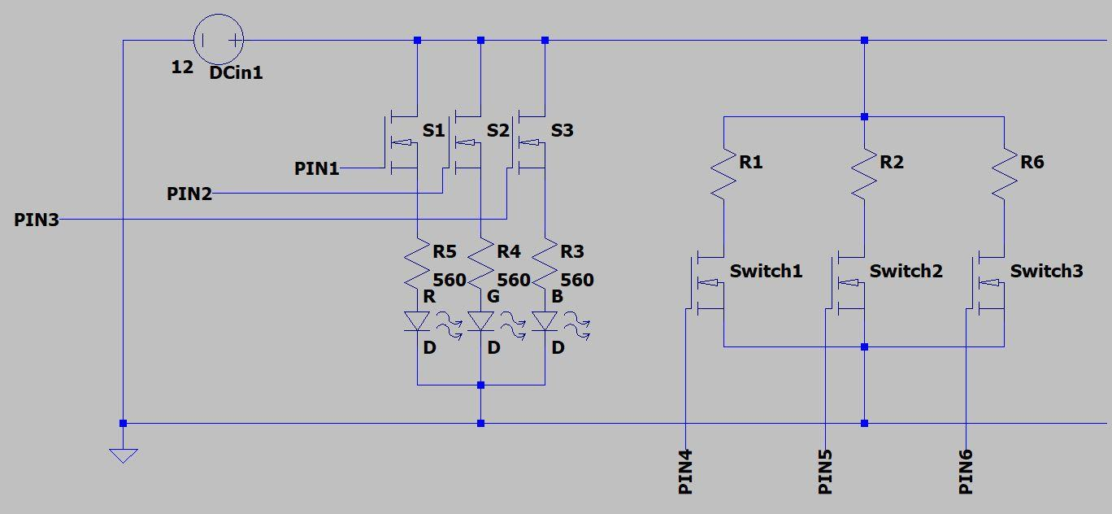

*Figure 5: Preliminary LED Control Via MOSFET Switches*

* 1. **House Heating Energy and Cost Calculations**

We completed all the required research and calculations that would allow the team to simulate the house heating aspect of our project and calculate the cost of heating for the two energy sources, electricity and natural gas. This includes the rate of heat loss depending on house size and building material, and cost of energy depending on time of the year. Refer to Appendix 3 for a list of all formulas and constants.

# Technical Plan

* 1. **Web application**

*Task 1.* Brainstorm and Create Line Graphs

These graphs should show the relationship between inputs and outputs. There should be at least two graphs created.

*Task 2.* Implement interactive map hover functionality

*Task 3.* Connect the web application to Arduino

Firebase will be used to connect these two components. The primary firebase feature that will be used is the realtime database, a cloud-based key value store. The web application will use the Firebase JavaScript API to read and write values from Firebase.

* 1. **Arduino**

*Task 1.* Write code and design the more optimal Red/Green LED Arduino control.

Design the circuit which will control the Red/Green LEDs (indication natural

gas/electric power) using decoders to reduce the amount of Arduino output

pins used.

*Task 2.* Write code and design the Red/Blue (R/B) LED Arduino circuit

Similar to the previous task, only this circuit will control the R/B LEDs

that represent the house heating up.

*Task 3.* Implement AC load reading

Write code to calculate the power flow equations, that would allow the Arduino to simulate actual load values. Additionally implement design that would read voltage and current information from the main circuit (i.e. the power grid and house circuitry), and save them to an array. The voltage can be probed and then calculated via reading in enough values and then calculating for the root mean square, while the current can be probed using AC current transducers. The calculation of the power flow equations would serve as a check for the accuracy of the probed values.

*Task 4.* Serial Communication Implementation

Setup the communication method between the Arduino and the web

application. This would consist of programming the ESP8266 Wifi Module and

assuring it interfaces with the web application backend correctly.

* 1. **Circuit**

*Task 1*. Research and gather resources on typical loads of homes and businesses

*Task 2*. Construct model circuits of the typical loads

*Task 3*. Research and gather resources on AC power grid systems

*Task 4*. Design a small-scale power grid incorporating the appropriate

power source, transformers, and circuit breakers

*Task 5*. Combine the power grid and load circuits

*Task 6*. Test the final circuit (grid + loads) and verify functionality and integrity with respect to the calculations and other components of the project

* 1. **Diorama**

*Task 1*. Gather components from BOM

*Task 2.* Create frame using wood planks

*Task 3.* Cut the pink foam to size then insert it into the frame and set it with glue. After this is done it can fit the back panel to the frame, before setting the panel in place the electronics will be mounted on it first.

*Task 4.* Create town layout

After this is all set up the town layout will begin. Resin 3D printed houses will be utilized for this town. After printing, they will be painted in a realistic scheme. Once that is done the buildings will be stencilled onto the pink insulation foam and the ground covering for the diorama will be created. This will include adding roads, static grass and some electrical poles running from the power plant and to the houses.

* 1. **Integration of Project Components**

*Task 1.* Integrate all project components

This means the power grid circuit, the Arduino, the diorama, and the web application will be brought together for final system testing.

*Task 2*. Test the final system

Run the system while looking for flaws or failures.

*Task 3.* Fix and adjust the project

After testing the system, making sure that any mistakes are fixed and attended to. Improving on the design if possible. This is the “final touches” stage.

# Budget Estimate

|  |  |  |
| --- | --- | --- |
| **Item** | **Description** | **Cost** |
| 1 | R/YG Bicolor LED, Indicate gas/electric heating | $2.88 |
| 2 | R/B Bicolor LED, Indicate house temperature | $3.87 |
| 3 | RF Module Transceiver | $6.27 |
| 4 | 220 Ohm resistor | $1.83 |
| 5 | ARDUINO MEGA2560 ATMEGA2560 | $38.50 |
| 6 | Prototyping jumper wires | $4.95 |
| 7 | 2” x 6” x 16' plank | $12.14 |
| 8 | Pink insulation foam | $20 |
| 9 | Vinyl grass covering | $9.70 |
| 10 | Faux trees | $25 |
| 11 | Road paint | $7 |
| 12 | Black wire | $9 |
| 13 | N-channel Enhancement Mode MOSFET (Model 2N7002-7-F) x 100 | $7.04 |
| 14 | Capacitors | ≈$15 |
| 15 | Inductors | ≈$20 |
|  | **Total Cost** | **$183.74** |

The project is not resource intensive. The most expensive part is the Arduino Mega and it is less than 39 dollars. Thus, the project does not have any budget implications or constraints.

# Attachments

# Appendix 1 – Engineering Requirements

Team # 17 Team Name: The Future of Heat

Project Name: Future of Heat

|  |  |
| --- | --- |
| **Requirement** | **Value, range, tolerance, units** |
| Power source | 12V AC - stepped down from wall outlet |
| Loads | At least 4 homes with LEDs |
| Transmission/  Distribution | Power to loads through voltage lines |
| Safety | No exposed live wires; proper insulation |
| Dimensions | 3 feet by 3 feet |
| Weight Limitation | 40lbs |
| Adoption Rates | Range from 0% to 100% |
| Weather control | Range from -20 F to 100 F |
| Adoption EVs | Range from 0% to 100% |
| Emissions | CO2 emissions produced during each month |
| Cost | Cost of heating comparison of electric versus natural gas |
| Responsivity Time | Model and web app should physically change to reflect the user input ≤ 5 sec. |
| Loading | MW load on power lines within ±2% accuracy; indicate if the power grid would overload. |

# Appendix 2 – Gantt Chart

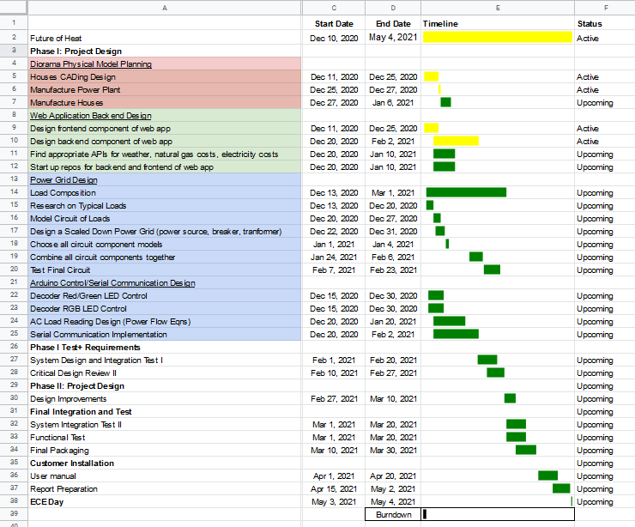

# Appendix 3 – Other Appendices

**Arduino Preliminary LED Control Design**

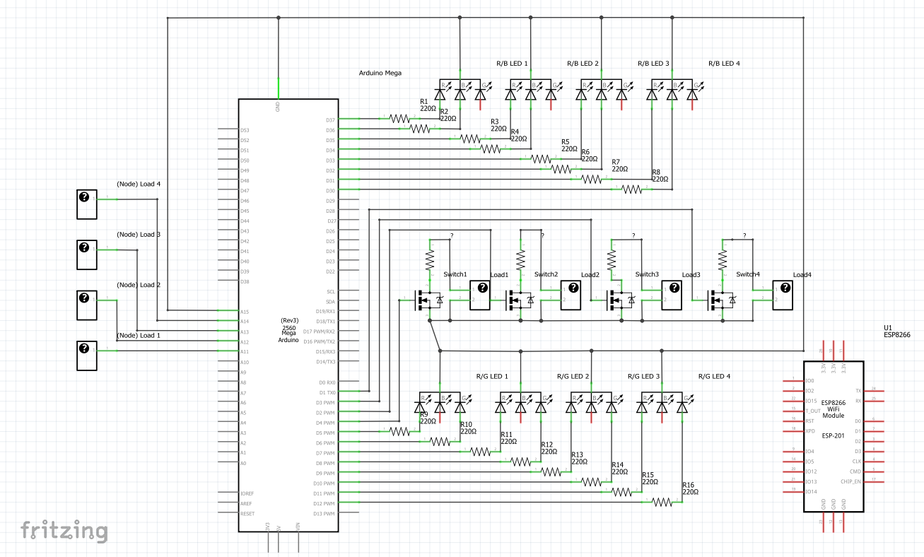

**Ardunio Power Readings Results**

|  |  |  |  |  |  |  |
| --- | --- | --- | --- | --- | --- | --- |
| Outputs | Vtheoretical | Vactual | V Error | Ptheoretical | Pactual | % Error P |
| 1(100 Ω) | V | 1.6446 V | 1.32% | W | 0.027 W | 2.8% |
| 2(200 Ω) | V | 3.3282 V | 0.154% | W | 0.0553 W | 0.46% |
| 3(300 Ω) | 5.0 V | 4.9922 V | 0.156% | W | 0.08306 W | 0.328% |

**House Heating and Cost Calculations**

House heat loss formulas:

- Total heat loss: Qhouse = Qtransmission + Qair leakage

- Heat loss due to transmission of heat through house structures: Qtransmission = Qwalls + Qceiling + Qfloor

o Qwalls = A U (tin – tout)

o Qceilings = 1.15 A U (tin – tout)

o Qfloors = A U (tin – tearth)

o Where: A = Area of surface (m2)

U = overall heat transmission coefficient (W/m2K)

t = Temperature

- Heat loss due to ventilation: Qair leakage = Cp ρ qv (tin – tout)

o Where: Cp = specific heat of air (J/kg K)

ρ = density of air (kg/m3)

qv = air volume flow (m3/s)

- Chosen house-dependent values*:

o Overall heat transmission coefficient U (W/m2K):

For walls/floors = 3.9

For roofs = 0.9

o Air volume flow qv (m3/s) = 25.97

o Area of surface A: assuming an average house in MA is 162.3 (m2) and an average roof height of 2.74 (m); A = 34.9 (m2)

Cost of heating:

- Cost of heating per seconde C = Qhouse P ÷ ƞ

o Where: P = price of fuel per unit of energy (cents/MJ)

Ƞ = efficiency of the heating device

- Price of fuel (cents/MJ); constants and APIs:

o Electricity = 3.06 (Or use API to get up-to-date data from U.S. Energy Information Administration:<https://www.eia.gov/opendata/qb.php?category=1012&sdid=ELEC.PRICE.MA-RES.M>)

o Natural Gas = 1.44 (Or use API to get up-to-date data from U.S. Energy Information Administration:<https://www.eia.gov/opendata/qb.php?sdid=NG.N3010MA3.M>)

- Efficiencies:

o Electric hearts/heat pumps: 100%/300%* (* 300% because heat pumps can get a coefficient of performance of up to 3)

o Gas Furnaces: 84%

**References**

Chan, Wanyu R, Price, Phillip N, Sohn, Michael D, and Gadgil, Ashok J. Tue .

“Analysis of U.S. residential air leakage database”. United States.

doi:10.2172/816784. <https://www.osti.gov/servlets/purl/816784>.

“Transmission Heat Loss through Building Elements.” Engineering ToolBox, 2004.<https://www.engineeringtoolbox.com/heat-loss-transmission-d_748.html>.

“Calculation of power and energy needs for heating of buildings”. Finland.

<http://www.puntofocal.gov.ar/notific_otros_miembros/fin43_t.pdf>